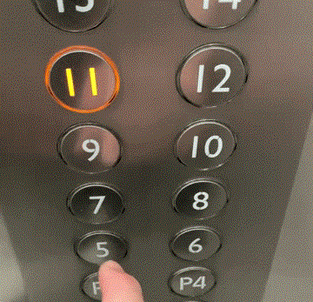

This is an example of the back elevator in the Park Tower of Lubbock.

The first noticeable issue is with the absence of any texture that would indicate a number. This may not be an issue with individuals with their sense of sight, but the absence of braille, or a feeling of the number itself, it restricts those who are visually impared.

Another noticeable issue is with the numbers proceeding from left to right instead of going directly upward. While it looks fairly nice, I believe that it would be better going up vertically first then moving to the next column for the next group of numbers.

In terms of necessary features, this elevator does not include either of the open or close door buttons. This feature is naturally included within most elevators, so to not include this creates a very confusing interface. To keep the doors open you have to press the button for the floor you are on for an extended period of time. To close the doors, I only found that it happens faster if you press another floor or hold another floor’s button down.

For each of these actions there is no set instructions for its usage, so you have to rely on intuition to operate. Through the usage of other elevators, however, this intuition is not reliable in this situation, causing confusion when the need to operate it delicately comes into fruition.

The feedback is created through the lighting of the buttons, and the arrows on the top of the elevator, along with a display above the door that tells the users which floor they are currently on. This number for the floor changes when the elevator begins to move, while the lights on the control panel’s buttons extinguish after the floor is reached.

Some mistakes that may be made during operation include:

Not holding the door for an oncomer in the distance, due to the missing open door buttons.

Those who are visually impared pressing the wrong button and getting off at the wrong floor.

This is a mockup of the elevator design with some improvements:

